# OOP – Multimedia Shop

The goal of this lab is to practice **Object-oriented programming** by building a Multimedia Shop System for managing different items – movies, books and games. The items can be **sold** or **rented**.

## Implementing Interfaces

Our multimedia shop will operate with **Items**. Most generally speaking, an item should hold an **id** (a unique identifier), **title**, **price** and a set of **genres**. The specific items our shop will have (for now) are **Movies**, **Books** and **Games**.

#### Step 1 – Item Interface

It's best to define the properties of an item in an **Interface**. Why an interface? We want our Multimedia shop engine to operate with **any item** (not just a specific class) – this allows **extendibility** in the future if we ever decide to add a new type of item.

* Create an interface describing the properties of an **item** – **id**, **title**, **price** and a **set of genres**. Name it correctly according to the C# naming conventions.

#### Step 2 – Rent and Sale Interfaces

Do the same for the **rents** and **sales** – define their own interfaces so our engine might work with the **idea of renting and selling items**, not some specific implementation.

* A **sale** should hold an **item** and the **date of purchase** of that item.
* A **rent** should hold an **item**. It should also hold a **rent state** (if the item is **returned** or **overdue**), the date of rent, deadline and date of return, and should also define a method (or property) for **calculating the rent fine** if a person returns the item after deadline.

#### Step 3 – Implementing the Interfaces

Now that we have our interfaces, it's time to implement them in actual classes.

* Create the **Item**, **Rent** and **Sale** classes and implement their respective interface.

Implementing is done by clicking on the interface and holding **[Ctrl + .]**.

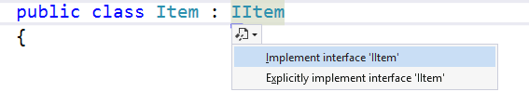

* All the interface members will be inserted into the class. Perform validations on the following fields:
  + **Item Id** – must be a non-empty string, at least 4 symbols long
  + **Item Title** – must be a non-empty string
  + **Item Price** – must be a non-negative number
  + **Rent Item** – must be a non-null Item
  + **Sale Item** – must be a non-null Item